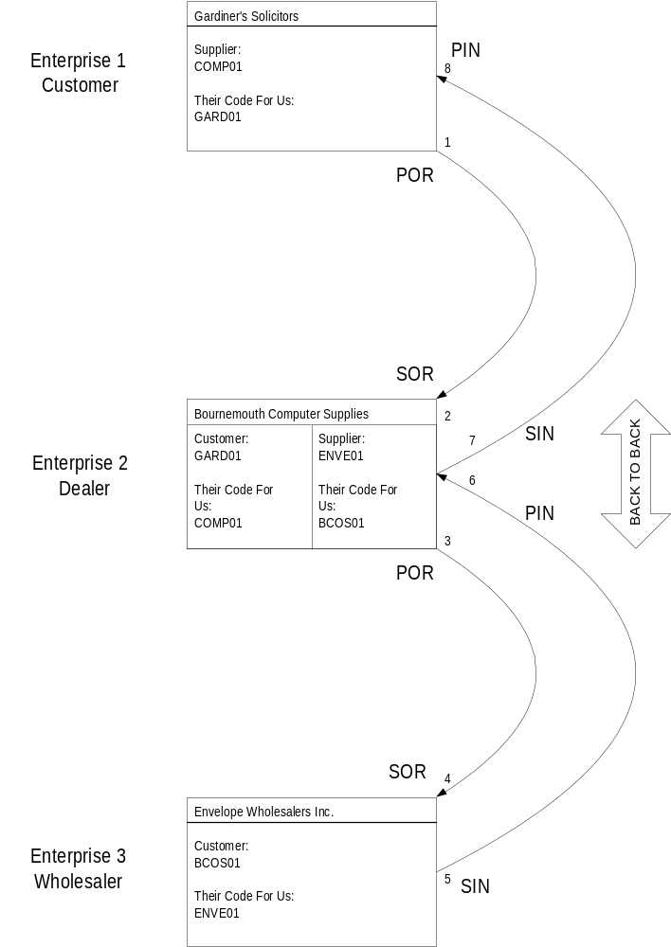

1 | Gardiner's Solicitors raises a Purchase Order from their supplier Bournemouth Computer Supplies for some envelopes
2 | The purchase order is received by Bournemouth Computer Supplies – they handle this as a Sales Order.
3 | Bournemouth Computer Supplies do not have sufficient stock and back to back the order raising a Purchase Order with their own supplier: Envelope Wholesalers Inc
4 | The Purchase Order is received by Envelope Wholesalers Inc as a Sales Order.
5 | Envelope Wholesalers fulfil the order and deliver and then issue a Sales Invoice to Bournemouth Computer Supplies.
6 | The received Sales Invoice represents a Purchase Invoice for Bournemouth Computer Supplies.
7 | Bournemouth Computer Supplies send a Sales Invoice back to Gardiner's Solicitors.
8 | Gardiner's Solicitors receive the Sales Invoice as a Purchase Invoice within their system to complete the seamless eBis XML back to back purchase scenario.

Point to Ponder …

In our dealer network we would be Enterprise 3 and our dealers would be multiple installs at Enterprise 2 level. Usually, dealers set us up as a supplier with a code of EXCH01 (I believe). That would mean that in our system we would have customers as follows…

Customer | Their A/C For Us
DEAL01 | EXCH01
DEAL02 | EXCH01
DEAL03 | EXCH01

So when we receive an order with a <BuyersCodeForSupplier> of 'EXCH01' which dealer is it from? That's why it's important that the dealer's also store what we call them. As then we would receive <SuppliersCodeForBuyer> 'DEAL01' so there can be no confusion. This sort of concept should be clear in the diagram.

